Birthday Celebration
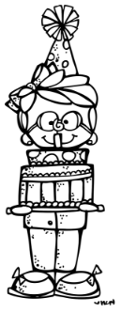
Of
__________________

Dear Parents,
Due to the growing number of food
Allergies, Avon East no longer allows Edible
Birthday treats to be sent into school.

We will still celebrate your child’s
Birthday! In the morning your child will find
a special birthday seat sack on his/her chair.
During morning announcements the name will
be announced and a card, pencil, and crown
from me will be given.

Also, you may send in a gently used or new
book to school with your child’s picture
glued into it and their name written with the
Date. Example: Shelly Ford 5-11-18
This book will be wrapped and your child
Will open their book and read it during
Read Aloud time. It will then be placed
in our Classroom library!

Thank you,
Mrs. Arndt

